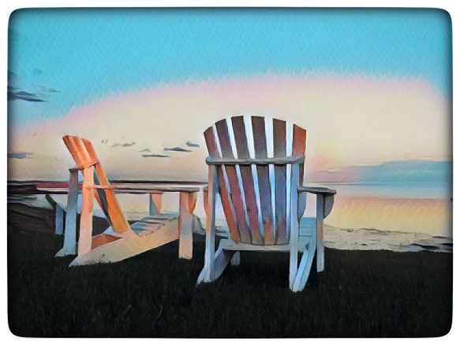By the Sea Counselling

It is a pleasure to meet you.

Please answer these questions for me to get to know you:

Name:

Age:

Gender:

Main Support:

Medications:

Goals for our counselling time together:

Thank you so much. Please return to Andrea Slysz at: aslysz@me.com

